They assaulted famous anesthesiologist who operated on Cristina

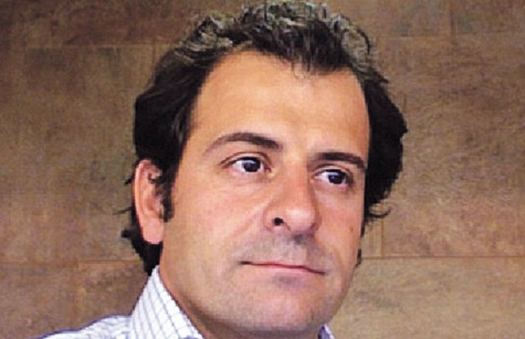
Este es el prestigioso anestesiólogo Fernando José Cacheiro

Exclusive . Criminals fell to Fernando José Cacheiro while with his family in a private neighborhood, Pilar party . They escaped with valuables .

BY: GROUP RECAP
10/24/2014 6:03:28

By Fernando Vazquez

Four robbers stormed a famous anesthesiologist , who , in 2012 , took part in the successful operation that President Cristina Fernandez underwent to remove a tumor in the thyroid gland. Criminals , carrying heavy weapons , reduced professional while he was with his family in a private neighborhood , in the locality of Manzanares in Pilar party . Marginal managed to leak , taking different valuables. Now, police investigations try to track down the thugs .

Spokesmen belonging to the judicial department of San Isidro revealed that the head of the family assaulted by the brutal sheaf was identified as Fernando José Cacheiro , 45, who works as an anesthesiologist .

It was learned that the incident occurred when the man was accompanied by his partner, the couple's children and their mother on a farm for the private neighborhood of San Francisco , which is located at the intersection of Rio Hondo and First Sergeant Lastra, a 59,500 kilometer route 8 , in that district , north of the provincial suburbs.

dramatic moments

Suddenly , 4 individuals , armed with revolvers and shotguns , entered the premises and then gained access to housing for the homeless , who declined.

Very quickly , the outlaws stole jewelry, money and cell phone devices . The thugs fled.

Illicit was reported in the detachment Manzanares , whose police try to track down the thugs . In this regard , the authorities consider that the thieves acted broadcast .

Cacheiro -recognized anestesiólogo- was one of the professionals who participated in the operation to which the president of our country was presented on January 4, 2012 at the Hospital Austral in Pilar.
The intervention was conducted by Pedro Saco, one of the most hierarchical specialists in the treatment of cancer in the head and neck . The medical team was completed with doctors Roque Adam and Ana Inés Voogd , and Fernando Siava Cacheiro and anesthetists.

